RESUME

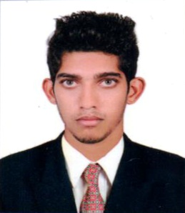

SHAHSAD .A
Email: Shahsadsaheer@gmail.com
Mobile: +919895789224

Objective

A challenging position as a Systems/Network Administrator academic knowledge and experience in the best possible method where I can deploy and use my technical, academic knowledge and experience in best possible method.

Summary

I have completed my graduation in Bachelor of Computer Application from India Karnataka University. I was employed with Teresa technologies as a computer hardware engineer for one year. During my tenure, I have gained much information and expertise about the networking industry. I believe that my experience and handedness will add greatly towards the growth of your organization.

Technical Knowledge

Hardware skills
- Trouble shooting the networking related problems.
- Troubleshooting & maintenance of PCs
- Fault finding & trouble shooting of Monitor, SMPS, and Mother Board
- Installation of Operating Systems Win XP, Win 7, Win 8, Windows server 2008 R2 & 2012 R2
- Configuration of Printer, Modem, Scanner
Installation of device drivers & hardware components.

Networking skills
- Cabling & crimping for systems, hubs, switches & routers
- Network devices, Repeater, Hub, and Switches
- Topologies, Media Access methods
- TCP/IP services, IP addressing
- DHCP, DNS, IIS etc.

Work Experience

- Worked as computer hardware engineer at TERESA TECHNOLOGIES Kochi, Kerala. From September 2015 to October 2016.

Assembling of Computer, trouble shooting & maintenance of Desktop PC’s, Servers, Printers, Software Installation, Network Installation & Configuration

Education & IT Training

Education
- Bachelor of Computer Application 2013 to 2015
Shree Bharathi Group of Institution Mangalore

IT Training

- A+ , N+
- MCSA , CCNA

Personal Information

Name : Shahsad A
Address : Shanib abna kattampally,
kannur, Kerala 670011
Date of Birth : 16/08/1993
Gender : Male
Marital Status : Single
Nationality : India n
Know Languages : English, Hindi, Malayalam

Declaration

I do hereby declare that the details given above are true and correct to the best of my knowledge and belief.

